**University of Petroleum and Energy Studies**

School of Computer Science

Department of Cybernetics

**Graphics & Animation Tools**

**LAB FILE**

**(Session: 2020-2021)**

Course: B. Tech with Specialization in Open Source and Open Standards

Submitted To- Submitted By-

Dr. Durgansh Sharma Kunal Ojha

Associate Professor SAP ID -500063333

Department of Cybernetics Roll No. -R100217034

**Experiment 9-** Design of 3D Mountain Landscape using Blender.

Google Drive Link- <https://drive.google.com/drive/folders/1XfR2EI-KmyMJfc4o_TLWValWXagfHXcq?usp=sharing>

Step 1- Open blender and select new file type as general

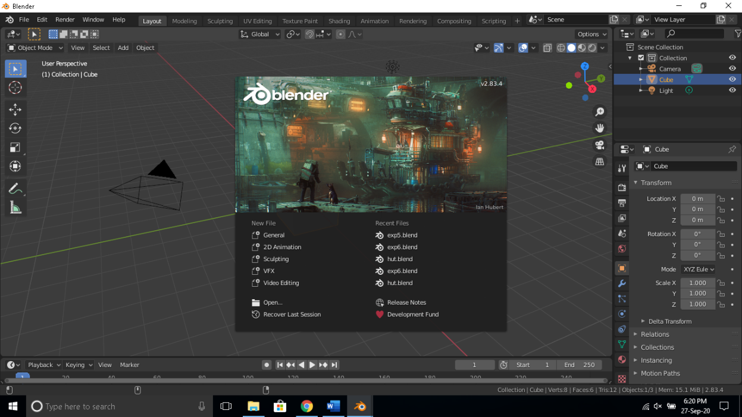

Step 2- Add a plane to the workspace in blender and name it terrain.

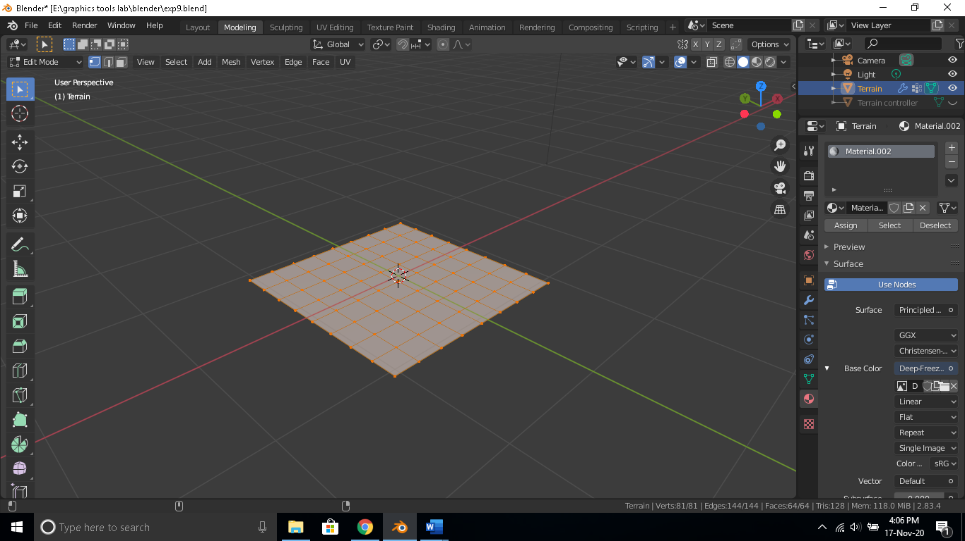

Step 3-Add a sphere and attach it to the plane as a displace modifier

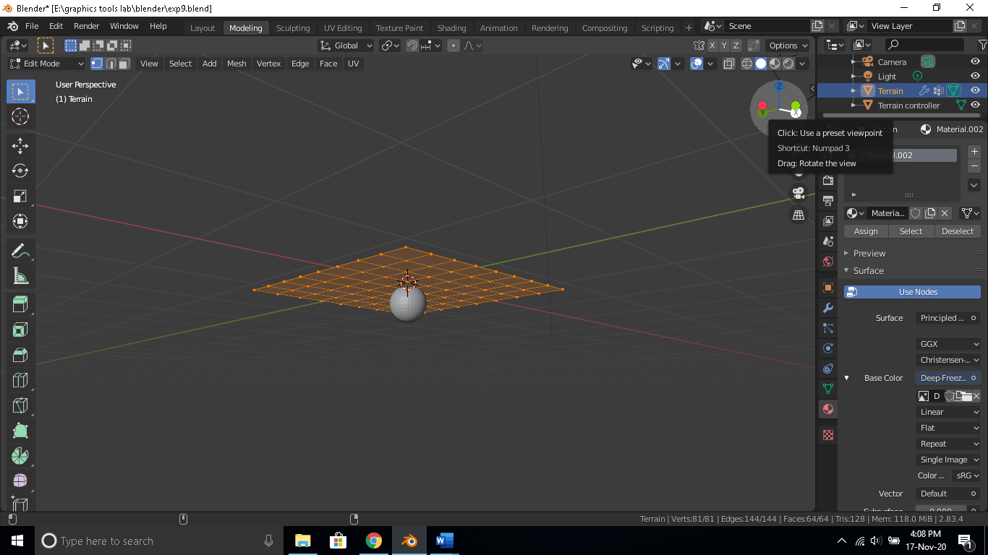

Step 4- Create a vertex group selecting all vertices in a plane. Add a Vertex Weight Proximity modifier on the vertex group and the target object as the plane, add a Subdivision modifier on the plane and arrange the subdivision as the first modifier, Vertex Weight Proximity as the second and displace as the third.

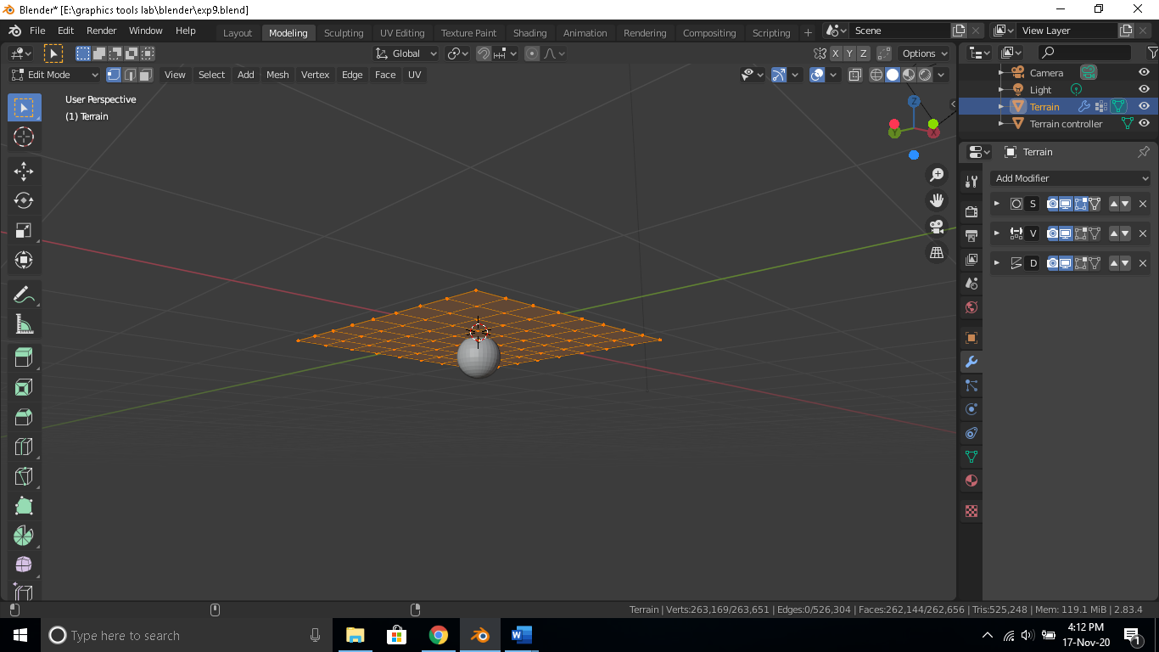

Step 5- In subdivision select the simple style and set render, viewport and quality to 6. Set the sphere as the object in displace modifier so that its movement shifts the shape of the plane and set the strength at 1.4 and midlevel at 0.Move the sphere until you get the following shape.

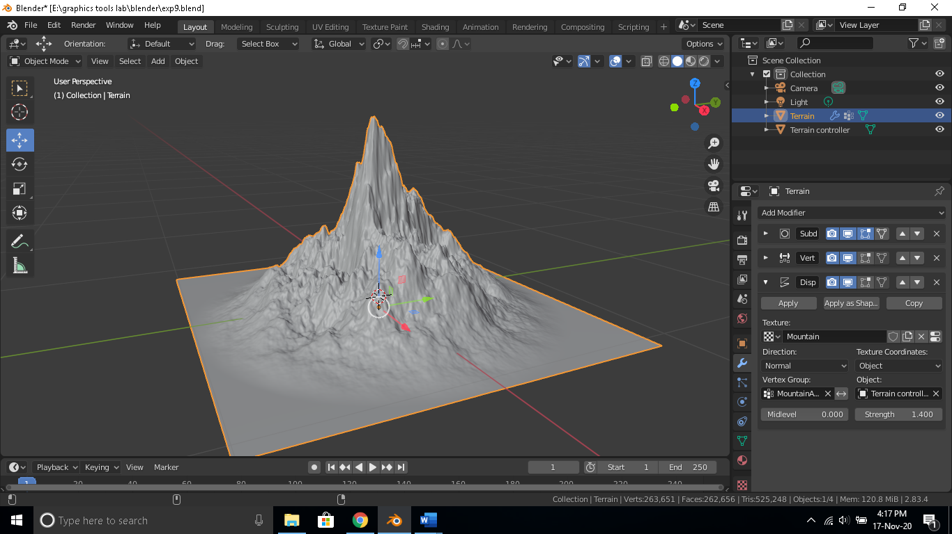

Step 6- Apply texture and colors as required and render the output.

